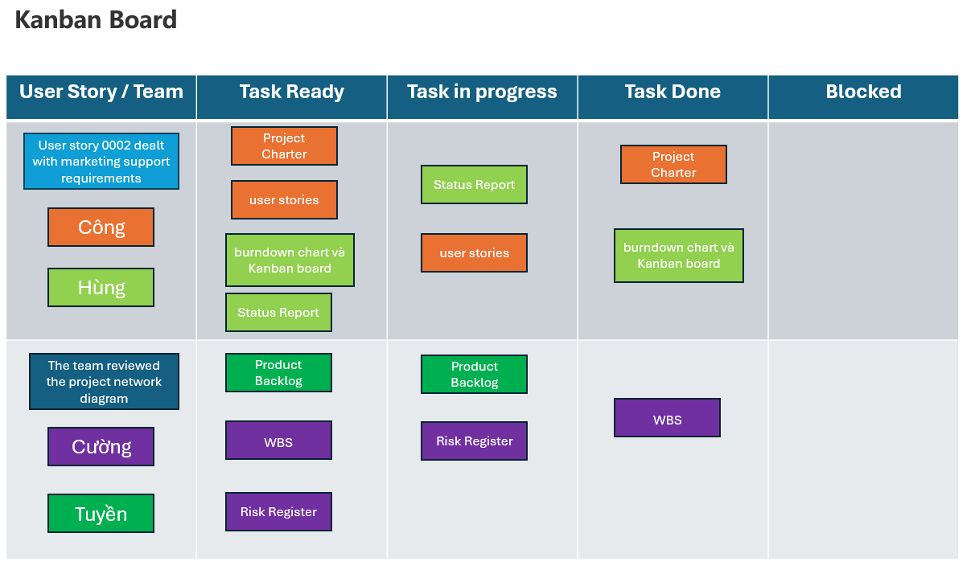

In this Kanban Board:

* Column one lists the user story by identifier and the team members who will accomplish the tasks. It is common for each team member to choose a distinct color for the jobs they are completing.
* Column two lists tasks ready for development by the team.
* Column three lists tasks in progress. Some teams apply "Work in Progress (WIP)" limits to manage workload to ensure the team is not trying to accomplish too many tasks simultaneously. WIP limits indicates limited resources or capacity.
* Column four lists tasks "Done." Recall the definition of "Done." Done indicates completed user acceptance criteria according to customer satisfaction.
* Column five shows tasks that are blocked. The Scrum Master asks each team member if there are any blockers at the daily Scrum meeting. Kanban board A displays blocked tasks. The Scrum Master addresses blocked tasks as soon as possible to ensure the Sprint can progress.